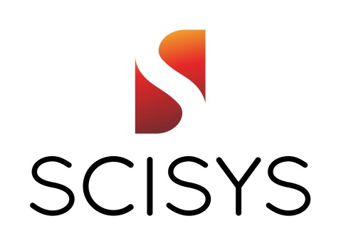

SCISYS Deutschland GmbH provides professional engineering and consultancy services supporting space programmes and missions. We have a strong presence at ESOC and EUMETSAT, as well as serving all ESA sites and spacecraft primes. Our team is composed of university graduates and experienced professionals, comprising some of the most knowledgeable, dedicated and talented engineers across Europe. Our services cover the whole life cycle of space programmes from early concepts to operations.
Our Space Division provides a dynamic, supportive and friendly atmosphere in which you are encouraged to lead with initiative. We support new ideas from our colleagues and are focused on innovation. Moreover, we actively manage your professional development, training and career progression.
For the location in Darmstadt (Germany) we are looking for a Copernicus Marine Applications Expert to work at EUMETSAT.

Tasks:
The marine applications expert will provide support towards the marine/oceanographic user community. In particular, he/she will support the interactions between EUMETSAT and the Copernicus Marine Environment Monitoring Service (CMEMS). In addition, he/she will provide subject matter expertise to the teams responsible for the promotion of satellite data towards the wider user community.
The main tasks of the key person are:

- Support to the marine data stream: Prepare and maintain an interaction plan with the Marine user community CMEMS and the wider user community e.g. Group for High Resolution SST (GHRSST),
International Ocean Colour Coordinating Group (IOCCG), Ocean Surface Topography Science Team (OSTST), etc.
- First-line support to marine product enquiries: Working with the User Helpdesk team the key person shall provide first line Support and respond to user’s questions relating to EUMETSAT’s marine data and products. The User Helpdesk is available during normal office hours
- Support the evolution of information on the Copernicus marine products:
- Support to web information (e.g. Product Navigator entries, Case Studies etc.);
- Provide expert input to future evolutions of EUMETSAT’s products, data services and user support services towards the marine and oceanographic user communities;
- Provide expert input to future evolutions of EUMETSAT’s products, data services and user support services towards the marine and oceanographic user communities;
- Support to CMEMS:
- Prepare the Agenda and record meeting minutes of the regular coordination meetings between EUMETSAT and CMEMS and track actions arising from this coordination;
- Support the reporting on the Copernicus Key Performance Indicators (KPIs) through the monitoring and assessment of user uptake of the Copernicus marine data.
- Support to Science: Support the marine product release process (e.g. support the marine product
validation process as needed and support the preparation of user release notices).
- Support to Training:
- Assist the user training team as an expert in marine training activities;
- Adapt relevant training material into web information for the wider marine user community;
- Prepare case studies that show potential applications of the marine data for users.
- All tasks and deliverables shall be performed in accordance with relevant EUMETSAT working practices and guidelines, and the key person is asked to support the maintenance of these practices and guidelines.

Essential requirements:
In addition to having a university degree, or equivalent, in oceanography or a related discipline, the key person shall have a minimum of 5 years' experience in the following areas:

- In depth knowledge and understanding of the relative value of satellite observations and other observations in marine and oceanographic applications;
- Good knowledge of marine data products and algorithms at least in one application area;
- Experience in working with or supporting an operational and/or research marine user community, and an understanding of the other;
- Experience in using satellite products and the related tools available to process/visualise them; an understanding of GIS based approaches and web map services is an advantage;
- Excellent communication skills;
- A demonstrated willingness and experience of sharing information;
- Good English writing skills;
- Knowledge of MS Office;
- High-level of autonomy in working arrangements and the ability to apply initiative and creativity in the execution of tasks.
Desirable requirements:
- Understanding the specific aspects and constraints of operational data processing environments;
- Experience in working in an international environment or with international partners or customers.

Other Information:
- Start date is February 2017.
- Fluency in English is mandatory.

